C.E. GISNO Subject: ENGLISH Teacher: ANDRÉ MATA

Name: ______________________________ Number: ______ Grade: 7th Date: ____ / ____ / _____

THE SIMPLE PRESENT TENSE
See the examples: |  |  |  |  | ESTRUTURA
- I drink milk.  - We drink water.  - She drinks juice. |  |  |  |  | SUJEITO + VERBO PRINCIPAL  (no infinitivo sem o to)
 |  |  |  |  | VERBO PRINCIPAL
 |  |  |  |  | Infinitivo | Passado | Particípio Passado | Tradução
 |  |  |  |  | to work | worked | worked | trabalhar
I work

You work
He works
3ª pessoa She works
do singular every day.
It works
We work
You work
They work
VERBO PRINCIPAL
Infinitivo | Passado | Particípio Passado | Tradução
to drink | drank | drunk | beber
É formado a partir do verbo principal no infinitivo sem a partícula TO.
Na 3ª. pessoa do singular,
(HE, SHE, IT),
o VERBO PRINCIPAL recebe S.
USOS: O presente simples é usado para expressar:
- verdades universais;
- ações habituais

EXERCISES A: | Complete as frases abaixo com o presente simples do verbo principal entre parênteses:

- I ____________________ in the park every day. (to walk)
- He ___________________ up early. (to get)
- You ____________________ Mathematics. (to like) 4) She _________________ good here. (to feel)
 | PARTICULARIDADES DA 3ª PESSOA DO SINGULAR (HE, SHE, IT)
REGRA GERAL |  | O verbo recebe S. | Ex.: | 1. to read – He reads.
PARTICULARIDADE  I |  | Verbos terminados em CH, SH, S, X, O ou Z recebem ES. | Ex.: | - to watch – He watches  - to fix – It fixes  - to go – She goes
PARTICULARIDADE  II |  | Verbos terminados em Y precedido de consoante mudam o Y para I e recebem ES. | Ex.: | - to study – He studies  - to try – It tries
PARTICULARIDADE  III |  | O verbo TO HAVE (ter), tem a forma HAS para a 3ª pessoa do singular. | Ex.: | - to have – He has  - to have – She has

EXERCISES B: | Complete as frases abaixo com o presente simples do verbo principal entre parênteses:

- I _________ to school in the morning and she ___________ in the evening. (to go)
- It _______________ the street. (to cross)
- She ______________ the soap opera every night. (to watch)
- I __________ lunch at school, but he ________ lunch at home. (to have)
2
II – THE SIMPLE PRESENT TENSE - NEGATIVE FORM
See the examples: |  |  |  |  |  | ESTRUTURA
- We do not drink milk.  - She does not drink juice. |  |  |  |  |  | ^{DO} VERBO  SUJEITO + + NOT + PRINCIPAL  DOES (no infinitivo sem o to)
VERBO PRINCIPAL |  |  |  |  |  | VERBO PRINCIPAL
Infinitivo | Passado |  | Particípio passado | Tradução |  | Infinitivo | Passado | Particípio Passado | Tradução
to drink | drank |  | drunk | beber |  | to work | Worked | worked | trabalhar
Coloca-se a partícula de negação NOT depois do verbo auxiliar DO ou DOES. |  |  |  |  |  | I do not work. I don’t work.  You do not work. You don’t work.  3ª. He does not work. He doesn’t work. pes. She does not work. She doesn’t work. sin. It does not work. It doesn’t work.  We do not work. We don’t work.  You do not work. You don’t work.  They do not work. They don’t work.
OBS.: Na 3ª pessoa do singular (HE, SHE,
IT), o verbo principal volta para a forma
de infinitivo sem o to, perdendo ou S ou ES ou trocando o IES por Y.
FORMA  CONTRAÍDA |  | do not = don’t does not= doesn’t

EXERCISES C: | Coloque as frases abaixo na forma negativa:

1) You like Mathematics. neg.: __________________________________________________________________________ 2) She speaks Portuguese.
neg.: __________________________________________________________________________ III – THE SIMPLE PRESENT TENSE - INTERROGATIVE FORM
See the examples: |  |  |  |  | ESTRUTURA
- Do we drink water?  - Does she drink juice? |  |  |  |  | DO  + SUJEITO + VERBO PRINCIPAL  (no infinitivo sem o to)  DOES
VERBO PRINCIPAL |  |  |  |  | VERBO PRINCIPAL
Infinitivo | Passado | Particípio Passado | Tradução |  | Infinitivo | Passado | Particípio Passado | Tradução
to drink | drank | drunk | beber |  | to work | Worked | worked | trabalhar
Coloca-se o verbo auxiliar DO ou DOES antes do SUJEITO. |  |  |  |  | Do I work?  Do you work?  3ª. Does he work? pes. Does she work?  sin. Does it work?  Do we work?  Do you work?  Do they work?
OBS.: Na 3ª pessoa do singular (HE, SHE,
IT), o verbo principal volta para a forma
de infinitivo sem o to, perdendo ou S ou ES ou trocando o IES por Y.

EXERCISES D: | Coloque as frases abaixo na forma interrogativa:

1) You like Mathematics. int.: ___________________________________________________________________________ 2) She speaks Portuguese.
int.: ___________________________________________________________________________
3
EXERCISES E: | Complete as frases abaixo com o presente simples do verbo principal entre parênteses:

- They _______________ alone. (to live)  - She ______________ Portuguese. (to speak)  - They ______________ every day. (to study)  - We ____________ everything. (to know)  - He ______________ a car. (to have)  - My mother ______________ every year. (to visit)  - They _____________ TV in the morning. (to watch)  - We ___________ well. (to dance)  - He __________________ in the park at night. (to play)  - I _____________ the newspaper every morning. (to read)  - They _____________ the homework. (to do) |  | ADVERBS
Usados no fim da frase:
every day = todo dia every week = toda semana every month = todo mês every year = todo ano today = hoje tonight = hoje à noite in the morning = pela manhã in the afternoon = à tarde at night = à noite
EXERCISES F: | Passe as frases abaixo no presente simples para as formas negativa e interrogativa:

1) They work hard every day.
neg.: ___________________________________________________________________________ int.: ____________________________________________________________________________ 2) He has a good job.
neg.: ___________________________________________________________________________ int.: ____________________________________________________________________________ 3) You do your best every day.
neg.: ___________________________________________________________________________ int.: ____________________________________________________________________________
4) She talks a lot every class.
neg.: ___________________________________________________________________________ int.: ____________________________________________________________________________ 5) I miss the English class.
neg.: ___________________________________________________________________________ int.: ____________________________________________________________________________ 6) We drink milk.
neg.: ___________________________________________________________________________ int.: ____________________________________________________________________________
☺ NAS QUESTÕES ABAIXO, USE NECESSARIAMENTE A FORMA ABREVIADA.
7) I kiss my wife every day.
neg.: ___________________________________________________________________________ int.: ____________________________________________________________________________ 8) She walks in the park every Sunday.
neg.: ___________________________________________________________________________ int.: ____________________________________________________________________________
4
✓ Leia o texto abaixo e responda as questões de A a F

FOOD VOCABULARY
1 Food is very important. We need to a = um, uma juices = sucos after = depois de kind = tipo
eat fruits, vegetables and meat to be in good and = e lunch = almoço
beans = feijões meals = refeições
health. We have to drink water, milk and juices beef = bife (carne de boi) milk = leite
bread = pão need = precisar
4 too. We have coffee and milk, fruit, juice fruit, breakfast = café da manhã of = de butter = manteiga one = um
cheese, jam, toast, cookies, bread and butter cheese = queijo or = ou chicken = galinha pie = torta
for breakfast. For lunch or dinner, we eat rice, coffee = café pork = porco cookies =biscoitos pudding = pudim
7 beans, eggs, vegetables, salad and one kind of dessert = sobremesa rice = arroz
eggs = ovos salad = salada
meat: beef, chicken, fish or pork. After these fish = peixe sweets = doces
for = para these = essas
good = bom, boa to be in = estar em
meals, we have a dessert: fruit, pudding, pie, health = saúde toast = torrada
ice cream = sorvete to = para
10 ice cream, fruit salad or sweets. is = é too = também
in = em vegetables = vegetais jam = geleia very = muito

- Combine as colunas adequadamente com base no significado das palavras:
( 1 ) dinner  ( 2 ) drink  ( 3 ) eat  ( 4 ) food  ( 5 ) fruit  ( 6 ) have  ( 7 ) health  ( 8 ) meat  ( 9 ) milk  ( 10 ) water | ( ) comida  ( ) fruta  ( ) carne  ( ) comer  ( ) beber  ( ) água ( ) jantar  ( ) leite  ( ) saúde  ( ) ter

- De acordo com o texto, escreva certo (C) ou errado (E) em cada frase a baixo:
- ( ) Nós precisamos comer apenas vegetais para estar bem de saúde.
- ( ) Não devemos comer salada no almoço.
- ( ) Frutas podem ser comidas tanto no café da manhã como podem ser servidas como sobremesas.

5
C) De acordo com o texto, escreva certo (C) ou errado (E) em cada frase a baixo:
- ( ) Desserts are after others meals.
- ( ) We eat cheese, Bread and butter for dinner.
- ( ) We have to drink only water.

- Responda EM PORTUGUÊS segundo o texto: Cite dois tipos de sobremesas:
_____________________________________________________________________________ _____________________________________________________________________________

- Responda EM INGLÊS segundo o texto: What do we need to eat?
_____________________________________________________________________________
________________________________________________________________________________

☺ Observe a figura abaixo e responda as questões A e B.
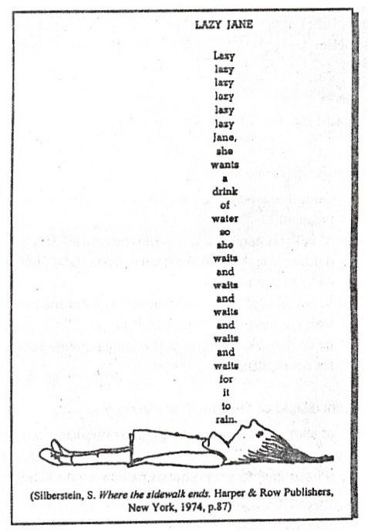
- Combine as colunas e descubra o significado das palavras de acordo com o texto:

( 1 ) Lazy ( ) água
( 2 ) wants ( ) quer
( 3 ) drink ( ) chover
( 4 ) water ( ) beber
( 5 ) so ( ) espera
( 6 ) waits ( ) Preguiçosa
( 7 ) rain ( ) então
- Por que Jane está nesta posição?
_________________________________
_________________________________
_________________________________
_________________________________ _________________________________
_________________________________
_________________________________
_________________________________
_________________________________

C.E. GISNO 6

EXERCISES G: | Traduza para o Português as frases abaixo no tempo presente simples:

- You study English every Tuesday.
res.: _____________________________________________________
- They like cars.
res.: _____________________________________________________________________ 3) Do you study alone?
res.: ________________________________________________________________ 4) She does not do the exercises.
res.: ________________________________________________________
- We don’t need help. res.: ________________________________________________________________
- Does it like milk?
res.: ___________________________________________________________________
EXERCISES H: | Traduza para o Inglês as frases abaixo no tempo presente simples:

1) Nós estudamos Português três vezes por semana. res.: ________________________________________ 2) Ela assiste TV todas as noites? res.: ________________________________________________________ 3) Eles não vão ao clube à tarde. res.: ________________________________________________________ 4) Peter não tem um livro de inglês. res.: ______________________________________________________ 5) Vocês fazem seus exercícios?
res.: _________________________________________________________ 6) Ele tem muitos amigos. res.: _____________________________________________________________

EXERCISES I: | Nas questão abaixo, MARQUE apenas a opção correta.

1) (VUNESP) He doesn’t ____ anymore. 3) (OSEC-SP) ____ like cheese.
- smoking c) smokes a) Mouses d) Mice
- no smoking d) smoked b) Goose e) Geese
- smoke c) Lice

2) (UNITAU-SP) Mon often _ when we _ a 4) (CEFET-PR) “The feeling of failure persists.” A joke. forma negativa correspondente a esse verbo
- laugh – tell b) laughs – tell é:
- laughs – tells c) laughes – tell a) doesn’t persist d) didn’t persist
- laugh – tells b) don’t persist e) wouldn’t persist
c) won’t persist

BLOG: andrematta.blogspot.com.br

C.E. GISNO 7

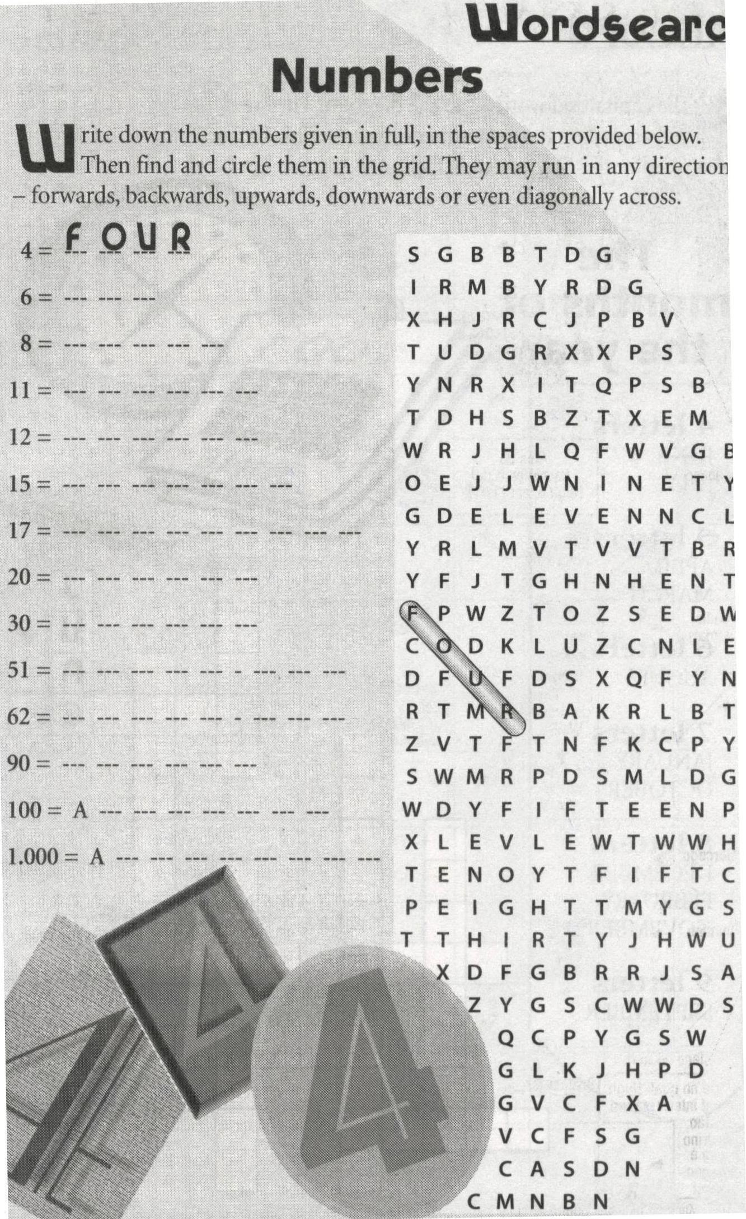

BLOG: andrematta.blogspot.com.br

